**GAP Analysis Document**

Of

**Admission module**

For Implementation of

**Campus Management Software**

at

**World Skill Center (WSC)**



**Sustainable Outreach And Universal**

**Leadership (SOUL) Limited**

Contents

A. Introduction 3

B. Overview of the Document 3

C. List of Screen 5

D. ADMISSION 7

1. Masters 8

1.1 Program Grades 8

1.2 Programs 8

1.3 Courses 8

2. Student And Instructor 9

2.1 Student 9

2.2 Instructor 11

3. Admission Master 12

3.1 Academic Calender Template 12

3.2 Eligibility Parameter 12

4. Application and Enrollment 12

4.1 Student Admission 12

4.2 Student Applicant 14

4.3 Program Enrollment 16

4.4 Course Enrollment 17

5. Councelling 18

5.1 Center Selection Master 18

5.2 Entrance Exam Declaration 19

5.3 Entrance Exam Center Allocation 19

5.4 Admit Card Generation Tool 20

5.5 Entrance Exam Admit Card 20

5.6 Entrance Exam Result Publication 21

5.7 Rank Card Publication Tool 21

5.8 Rank Card Publication Masters 22

5.9 Rank Card 22

6. Tools 22

6.1 Student Re registration Tool 22

# **Introduction**

The World Skill Center (WSC) is a premier advanced skill training institute established by the Government of Odisha, Skill Development and Technical Education Department, through the Odisha Skill Development Authority (OSDA). The WSC will impart advanced skill training in eight trades from engineering and service sectors. WSC caters primarily to induct the best talent from ITIs and Polytechnics and train them to become globally employable in emerging areas such as "Industry 4.0". WSC is housed in a state-of-the-art, 18-storey, air-conditioned building with nearly half a million square feet of space in the heart of capital city of Bhubaneswar.

With the Implementation of campus management software for WSC the goal is to streamline the operations and functions of the campus by integrating various processes, such as admissions, course registration, academic progress tracking, and financial management, HRMS, Procurement and Inventory management, etc into a unified system. The implementation also aims at providing a user-friendly interface for all stakeholders, making it easier for them to access the necessary information and complete their tasks with ease. The modules to be covered during the implementation of the software includes:

|  |  |
| --- | --- |
| Students Management Modules | Infrastructure Management |
| Academic System | Finance and Accounting System |
| Procurement & Inventory Management | Training and Placement |
| Human Resources Management System | Application Integration |

# **Overview of the Document**

The Gap analysis document is a detailed report that provides an overview of the

gaps between the current state of the project and the desired state, and develop recommendations to close those gaps. Conducting a gap analysis can help us to improve our product and profitability by allowing us to pinpoint “gaps” present in our software. Once it’s complete, we will be able to better focus on our resources and energy on those identified areas in order to improve them.

This document covers all the gaps between the existing software and functional requirements provided by WSC SME’s for Hostel module.

# **List of Screen**

The table below is list of screens present for the Admission module. Yes in Change in Existing column means that there will be change for a existing screen in the Campus management software, while Is new screen means the screen is not present in the existing software and will be newly developed. This document contains list of changes in existing screens, while requirements for new screens are covered in the SRS document.

|  |  |  |  |
| --- | --- | --- | --- |
| **SL no** | **Name of the Screens** | **Changes in Existing** | **Is New Screen ?** |
|  | Department | No | No |
|  | Program Grade | No | No |
|  | Program | Yes | No |
|  | Semester | Yes | No |
|  | Course | Yes | No |
|  | Topic | Yes | No |
|  | Class Room | No | No |
|  | Academic Year | No | No |
|  | Academic Term | No | No |
|  | Document Template | Yes | No |
|  | Academic Calendar | Yes | No |
|  | Student Admission | Yes | No |
|  | Student Applicant | Yes | No |
|  | Program Enrollment | Yes | No |
|  | Course Enrollment | Yes | No |
|  | Student | Yes | No |
|  | Instructor | Yes | No |
|  | Student Re registration Tool | Yes | No |
|  | Student Category | Yes | No |
|  | Student Batch | No | No |
|  | Fee Category | Yes | No |
|  | Fee Structure | Yes | No |
|  | Fee Schedule | Yes | No |
|  | Fees | Yes | No |
|  | Academic Event | No | No |
|  | Documents | No | No |
|  | Awards | No | No |
|  | Fee Types | No | No |
|  | Student Identity Card | No | Yes |
|  | Identity Card Tool | No | Yes |
|  | Center Selection Master | No | Yes |
|  | Entrance Exam Declaration | No | Yes |
|  | Entrance Exam Center Allocation | No | Yes |
|  | Admit Card Generation Tool | No | Yes |
|  | Entrance Exam Admit Card | No | Yes |
|  | Entrance Exam Result Publication | No | Yes |
|  | Rank Card Publication Master | No | Yes |
|  | Rank Card Publication Tool | No | Yes |
|  | Rank Card | No | Yes |

# **ADMISSION**

**Existing Student Admission Process Flow**

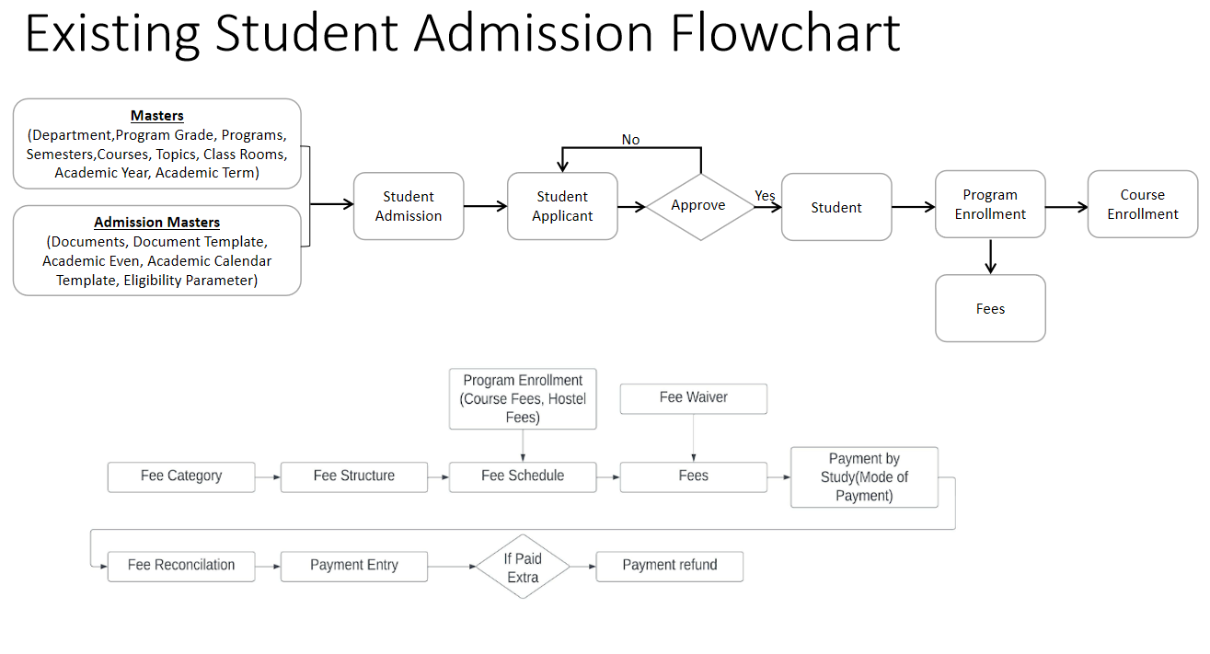

**WSC Student Admission Process Flow**

Entrance Exam Process

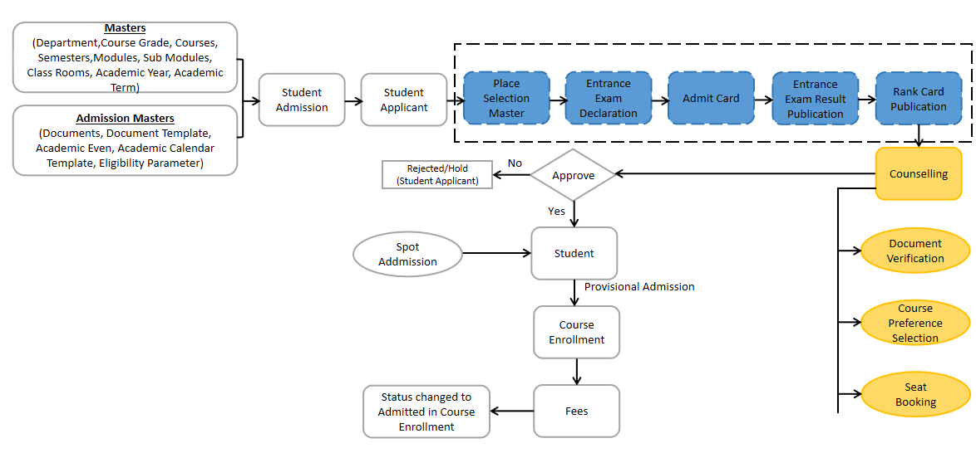

- No Change

- Gap Between Existing and WSC Process Flow

- Addition to the Scope

## **Masters**

### **Program Grades**

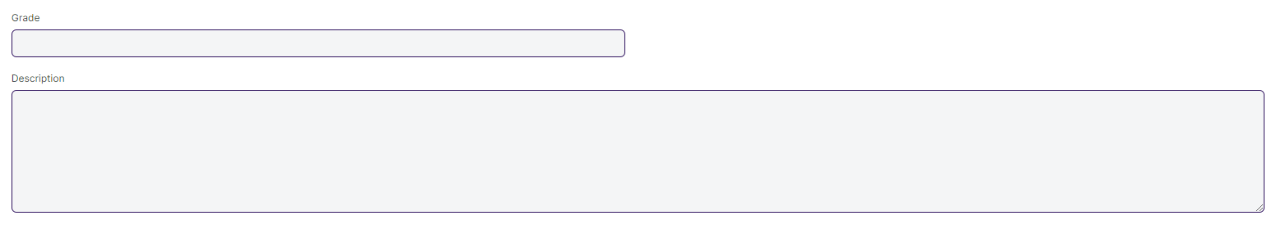

#### **Description of Changes:**

* Change the name of Program Grades to Course Grade.

### **Programs**

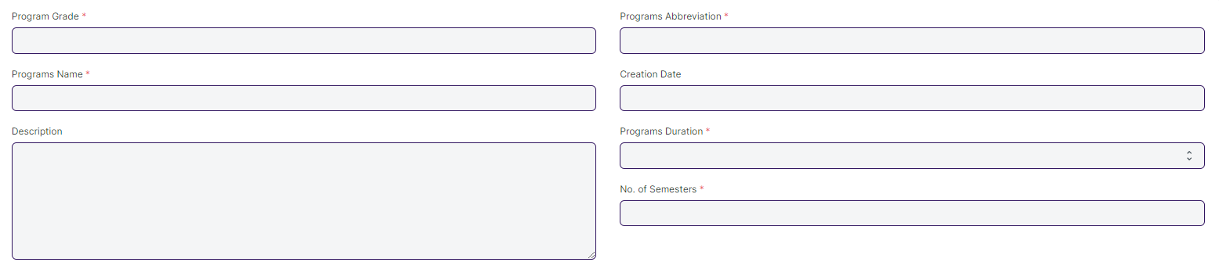

#### **Description of Changes:**

* The following name will be change:

1. Programs to Course
2. Program Grades to Course Grade
3. Programs Name to Course Name
4. Programs Duration to Course Duration

### **Courses**

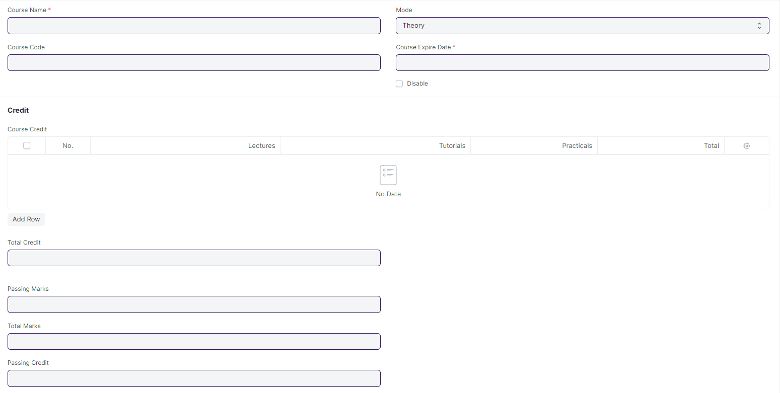

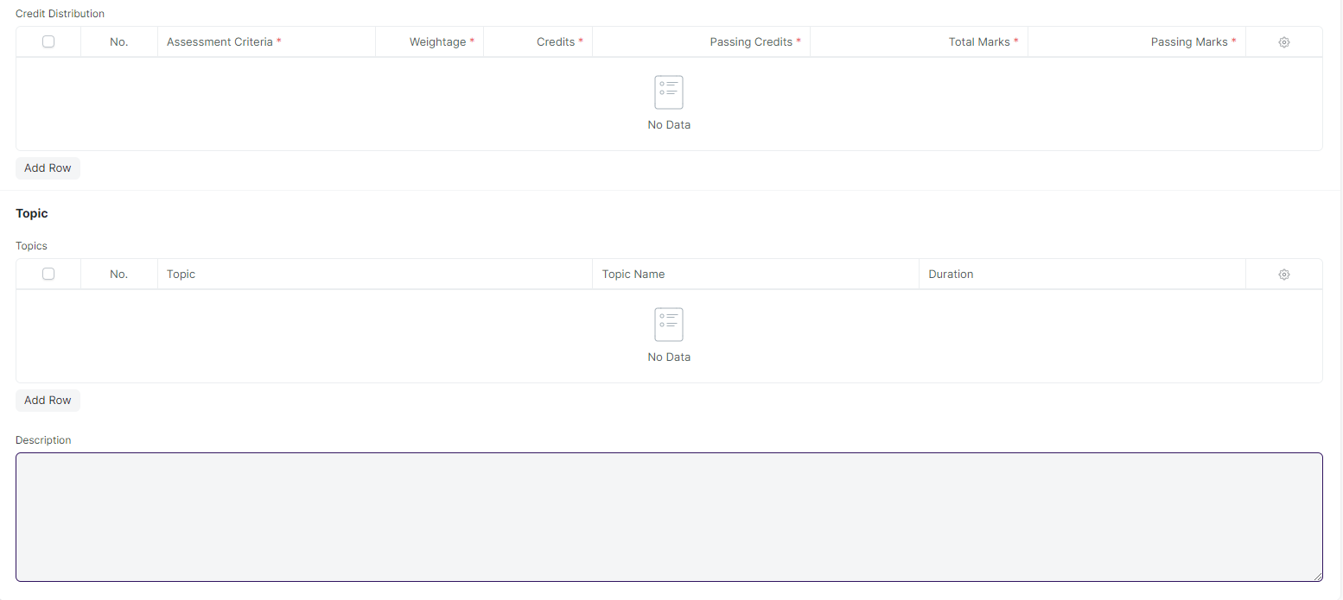

#### **Description of Changes:**

* The following name will be change:

1. Courses to Modules
2. Course Name to Module Name
3. Course Code to Module Code
4. Course Expire Date to Module Expire Date

* In Course screen's Topic table needs to be expanded to include the topic description field and a button for attaching the lesson plan.
* All the fields and table which is related to credit need to be hidden or deleted.
* In Topic Table following fields need to be added:

1. Topic Description.
2. Attach field for uploading the lesson plan.

## **Student And Instructor**

### **Student**

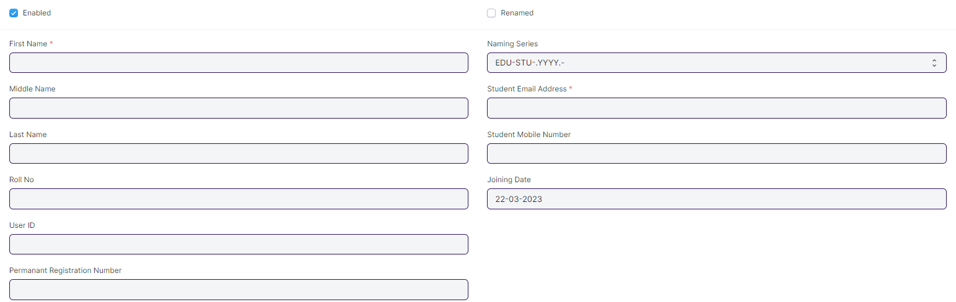

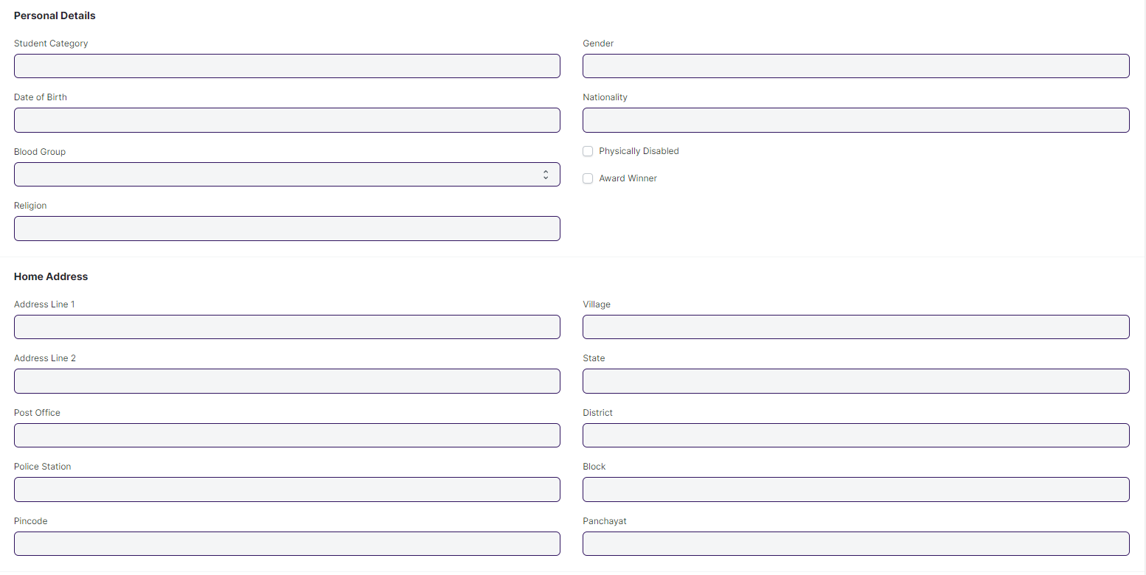

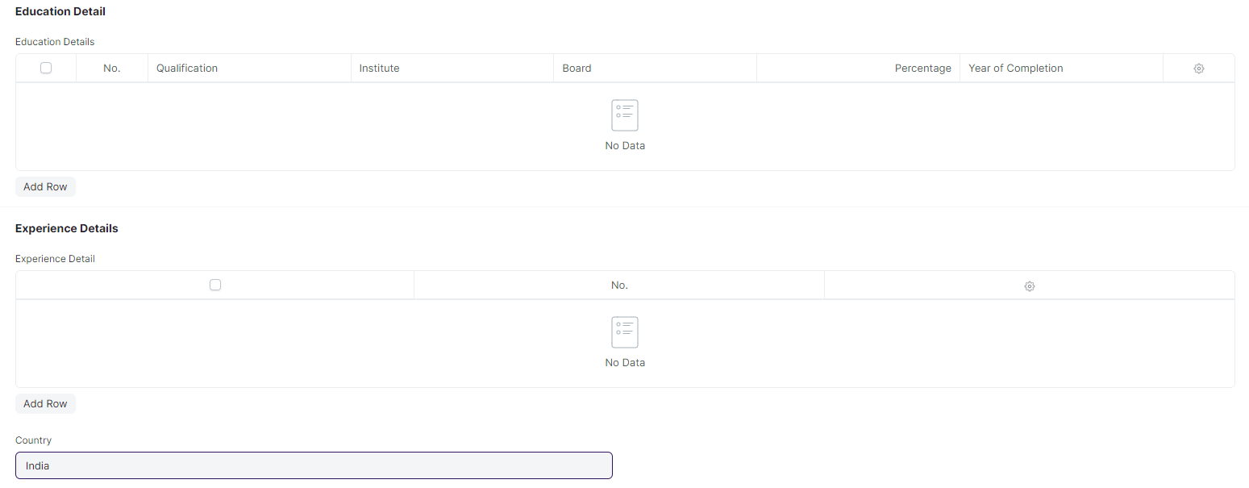

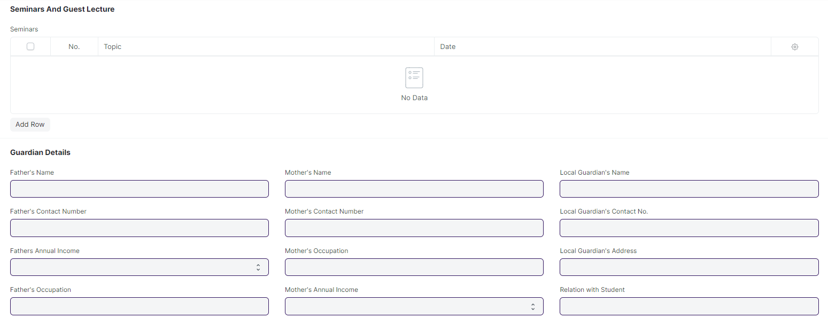

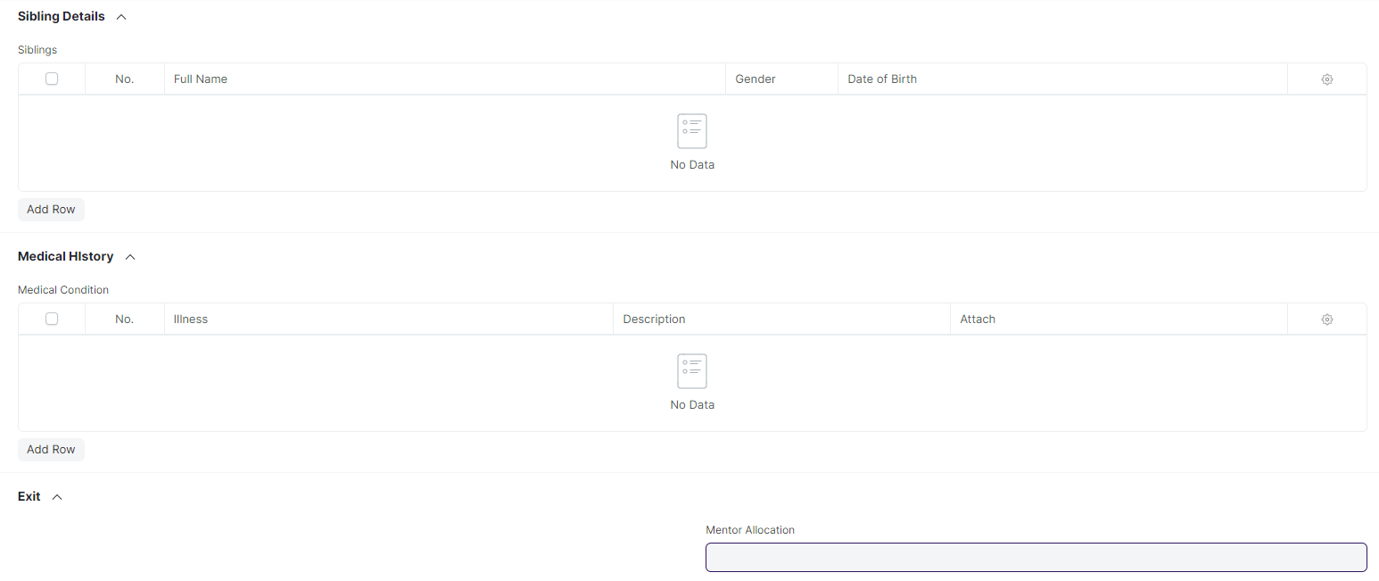

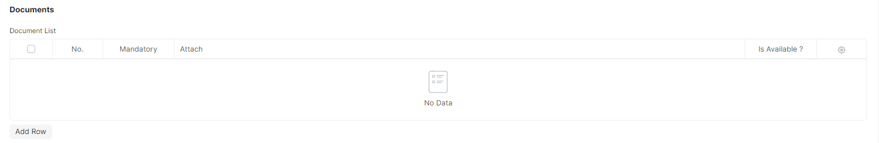

#### **Description of Changes:**

* In Current Education Child Table Programs name need to be rename to Course.

### **Instructor**

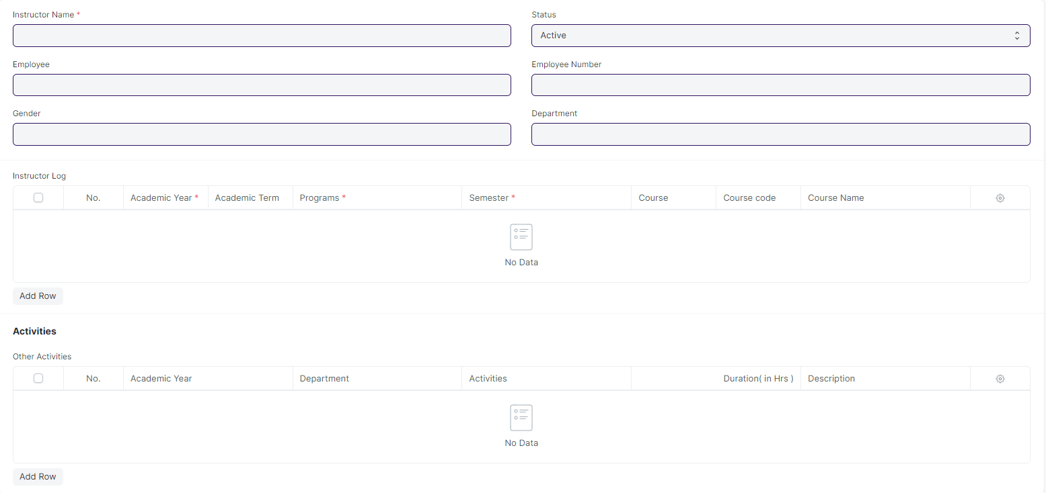

#### **Description of Changes:**

* In Instructor Log child table Programs , Course, Course Code and Course Name rename to Course, Module, Module Code and Module Name.

## **Admission Master**

### **Academic Calender Template**

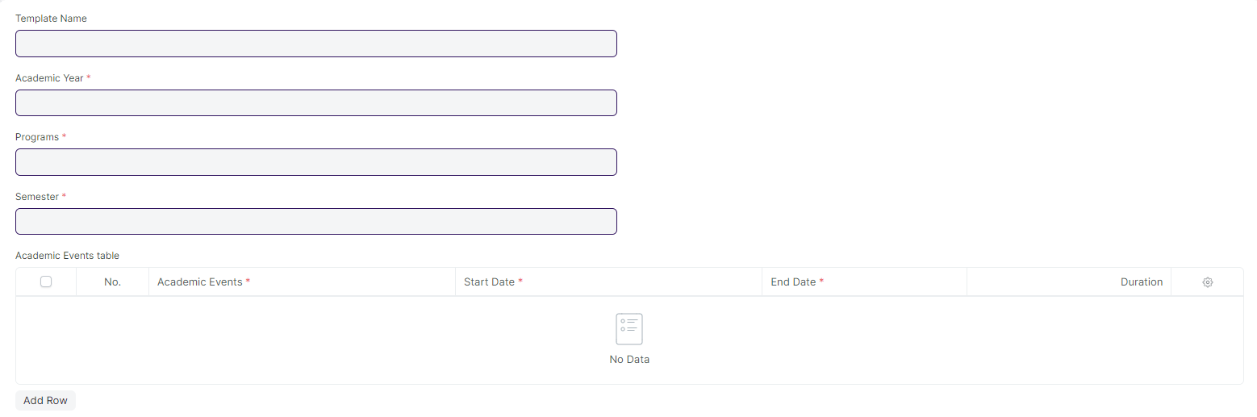

#### **Description of Changes:**

* Different Academic Events, such as Exam Dates, other academic events, and TOT events, should be displayed in a calendar view.

### **Eligibility Parameter**



#### **Description of Changes:**

* An age criteria should be added as an eligibility criteria.

## **Application and Enrollment**

### **Student Admission**

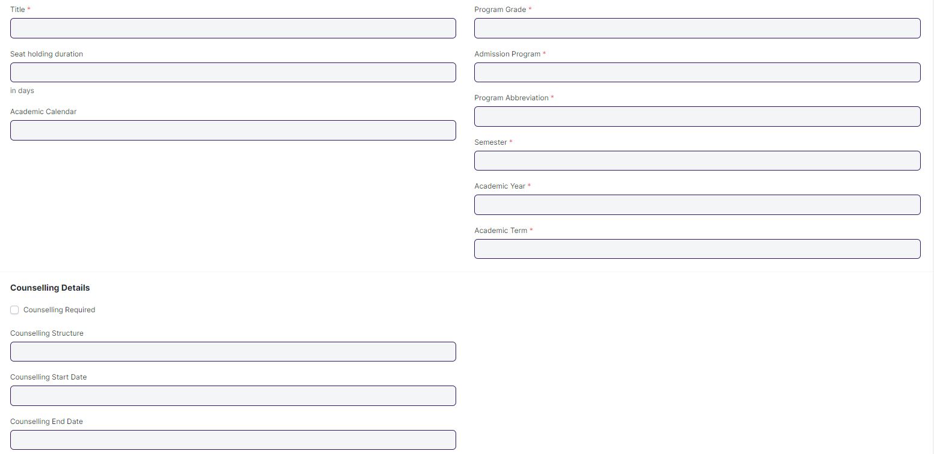

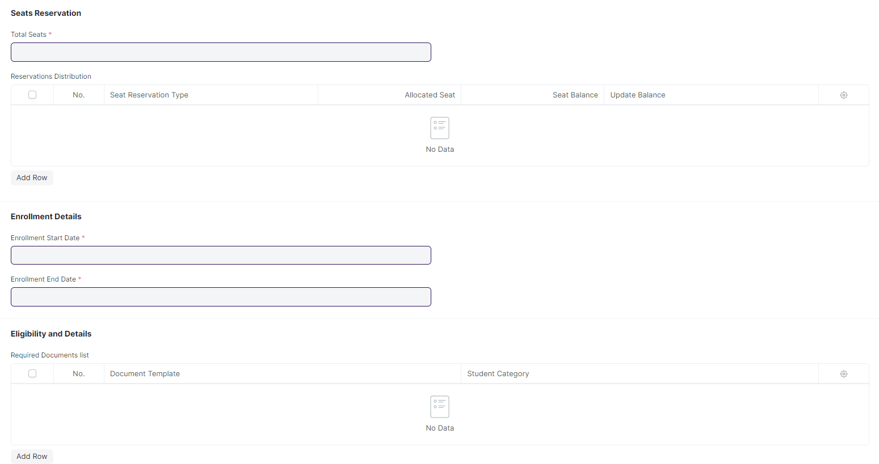

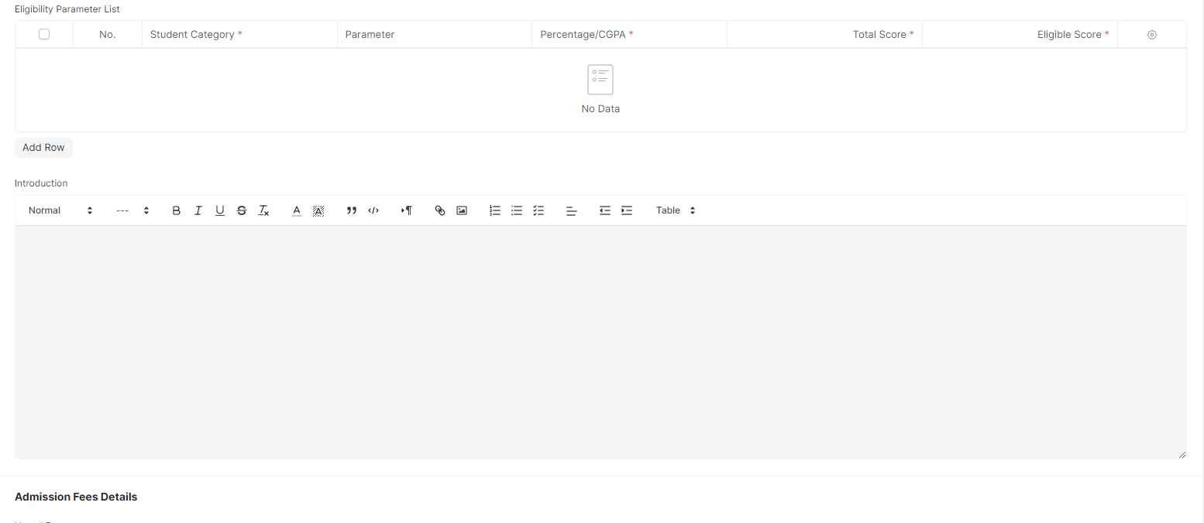

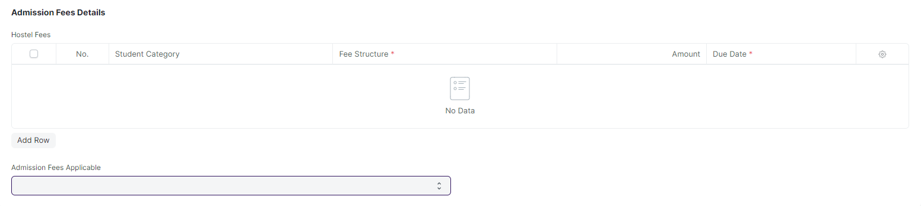

#### **Description of Changes:**

* The following name will be change:

1. Program Grade to Course Grade
2. Admission Program to Admission Course
3. Program Abbreviation to Course Abbreviation

* The age criteria field needs to be added.
* A student who applied and appeared for the entrance exam was selected for counselling but did not choose any course offered then he/she will be rejected.
* If there are still seats available at WSC, they will advertise for Spot Admission, which will allow both new and previously selected students to visit the WSC center to directly apply for admission without having to take a separate exam or fill out a separate form.

### **Student Applicant**

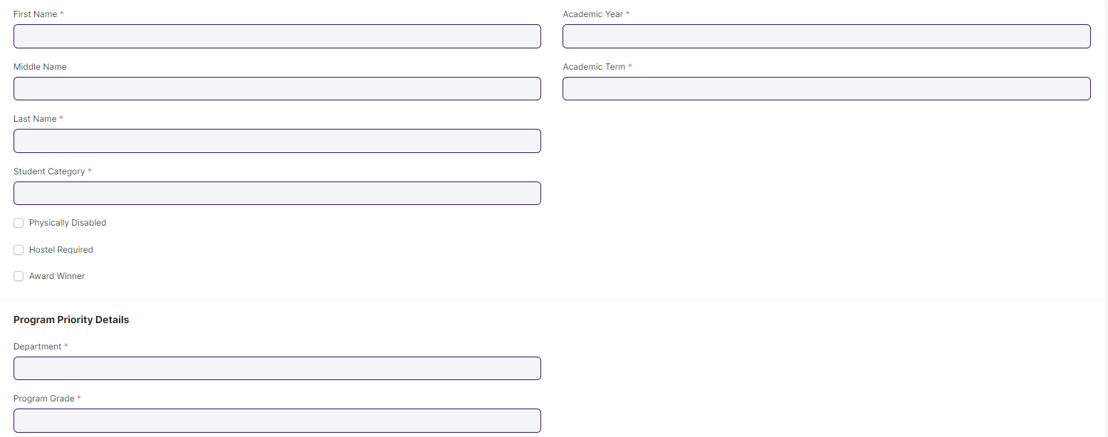

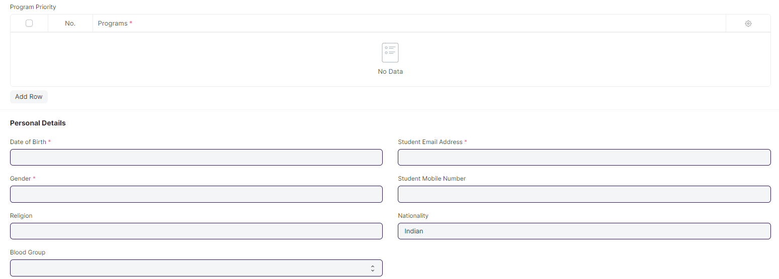

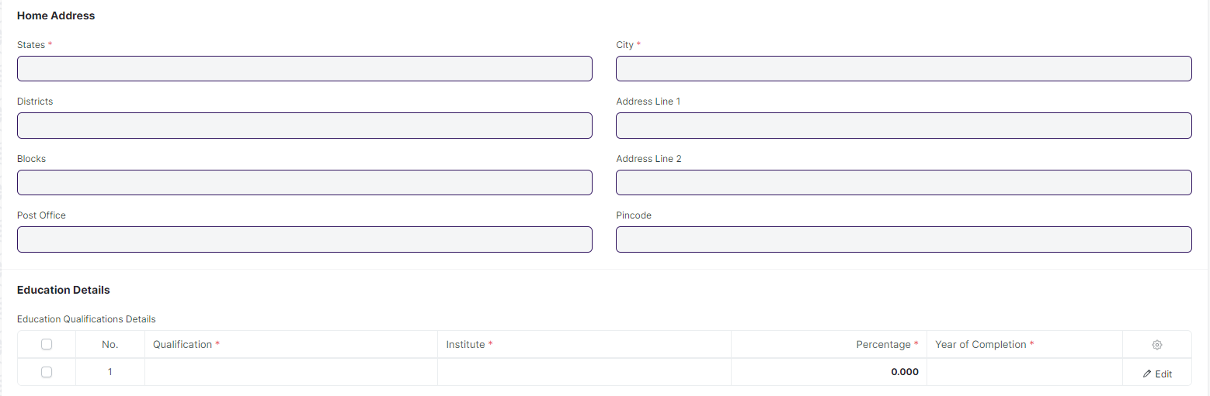

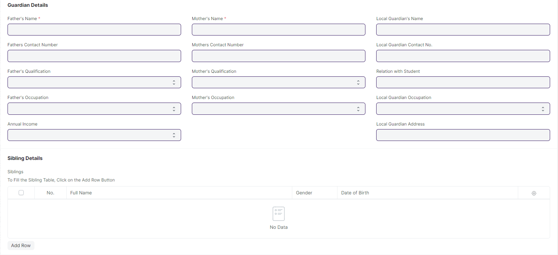

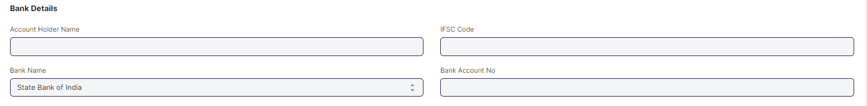

#### **Description of Changes:**

* The **Hostel Required** field will be hidden and the check-in will be set to the default value.
* The City field will be renamed as City / Town / Village
* An option needs to be added for selecting an entrance **Exam Centre** and **Exam City** preference.
* In Exam Center preference following field will be added:

1. State
2. District
3. City/Village/Town

* There will be a Course Choice option currently that will be consider in program priority child table.
* A 3 field needs to added ,General Based Rank, Category Based Rank and PWD based rank . These three fields will be read only and filled after rank card generation
* Some for child tables need to be regarding program priority.

1. Rank Based Program Priority: - In this table the applicant has to give their program preference after rank card generation. Also this table will only appear in the screen after rank card generation
2. Counselling Based Program Priority:- In this table the applicant will give their final program priority during counselling session. As per the program selected from this table the applicant will book a seat for provisional admission.

* The **age** must be validated against the age limit parameter.
* **Following fields will be mandatory:**

1. Email ID
2. Gender
3. Blood Group
4. DOB
5. State
6. District
7. Block
8. City / Town / Village
9. Address Line 1
10. Pincode

* The **Gender** field in the student applicant screen should only have the options of **Male, Female, and Other.**
* The **Email ID** is verified when signing up.
* An option should be available in the system which allows the applicant to apply for **both SOS and SOE**.
* Applicants for **SOE** must have either an ITI or a Diploma in Engineering.
* Applicants for **SOS** must have a +2 certificate or a diploma in any discipline.
* **Rank** will be determined by category, such as **SC Ranking, ST Ranking, General Ranking, OBC Ranking, Total Ranking, SC Woman Ranking, ST Woman Ranking**, and so on.
* **Re-counselling** is done for students who are not able to obtain their desired course.

**Remarks:** The removal of the Bank Details section should be discussed at a later date.

**Student Applicant Admit Card**

* The applicants will need to download admit cards from their portal, which will contain the **Date and time, venue, course, department, address and General instructions** applicable for both **SOE** and **SOS**.

### **Program Enrollment**

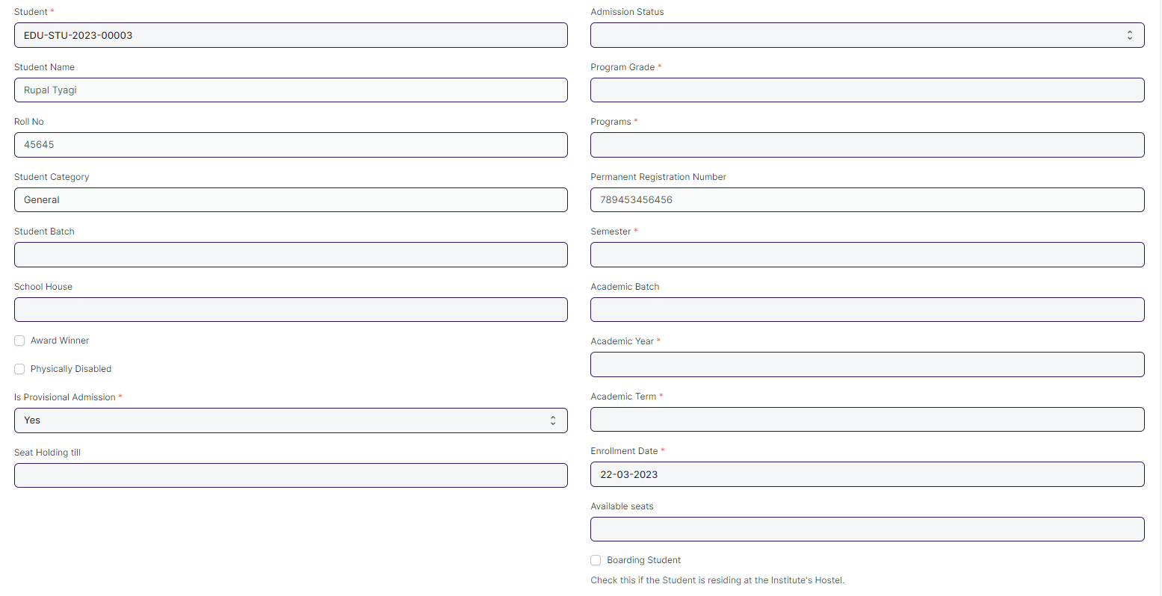

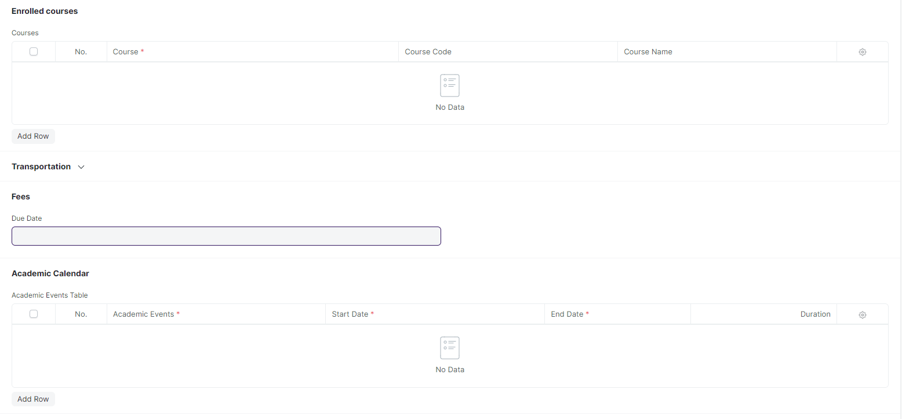

#### **Description of Changes:**

* The following name will be change:
  + 1. Program Grade to Course Grade
    2. Programs to Course
    3. Academic batch need to be deleted
    4. Enrolled Course child table and their respective fields need to be renamed to enrolled Module and course, course code and course name rename to module, module code and module name.

### **Course Enrollment**

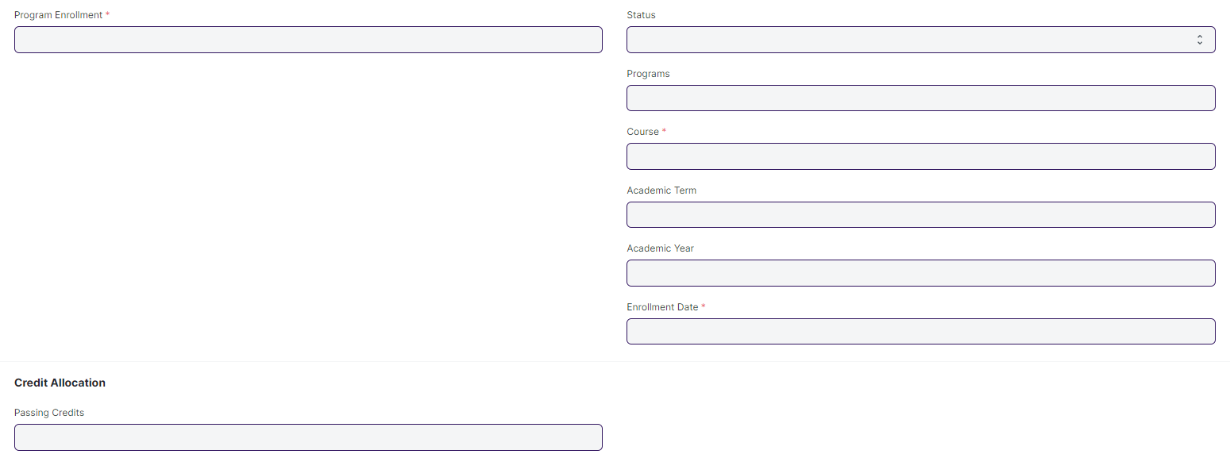

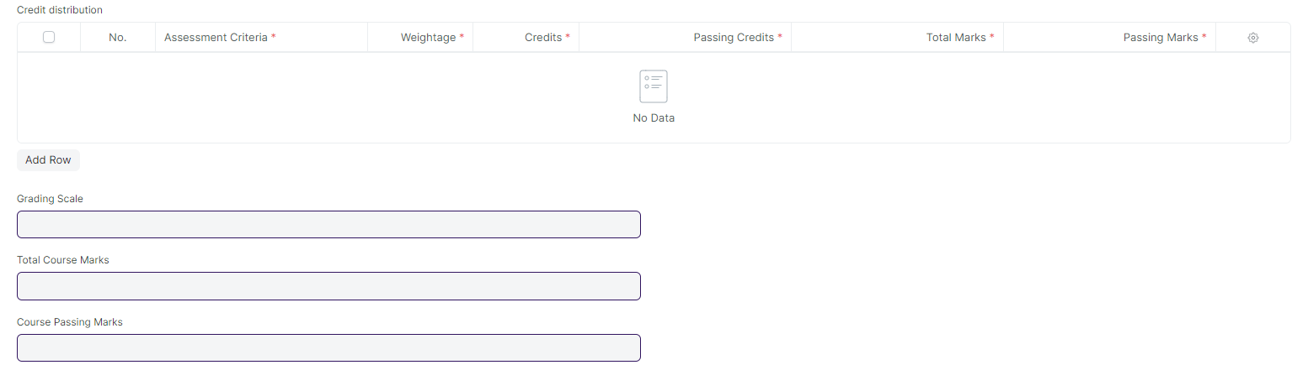

#### **Description of Changes:**

* All the fields and table which is related to credit need to be hidden or deleted.
* Fields need to be renamed:

1. Programs rename to Course
2. Course Rename to Module
3. Program Enrollment rename to Course Enrollment

## **Councelling**

**Note: All Screens mentioned below which are part of counselling are new screens that need to made**

### **Entrance Exam Center Master**

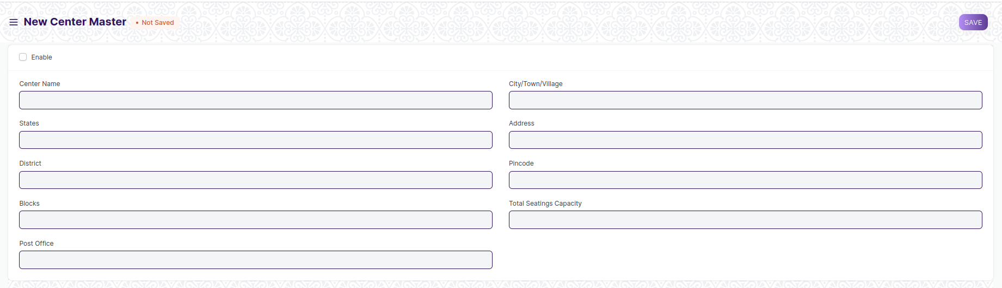

#### **Description of Changes:**

* **A new master screen where basic information regarding a exam centre is stored**
* Mandatory fields include:-
  + Center Name
  + State
  + District
  + Blocks
  + Post Office
  + City/Village
  + Address Line 1
  + Pincode

### **Entrance Exam Center Selection**

### Screenshot 2023-04-26 151417

#### **Description of Changes:**

* A screen where information regarding are exam centers that will be used for the upcoming entrance exams are stored
* Mandatory fields include:-
  + Academic Year

### **Entrance Exam Declaration**

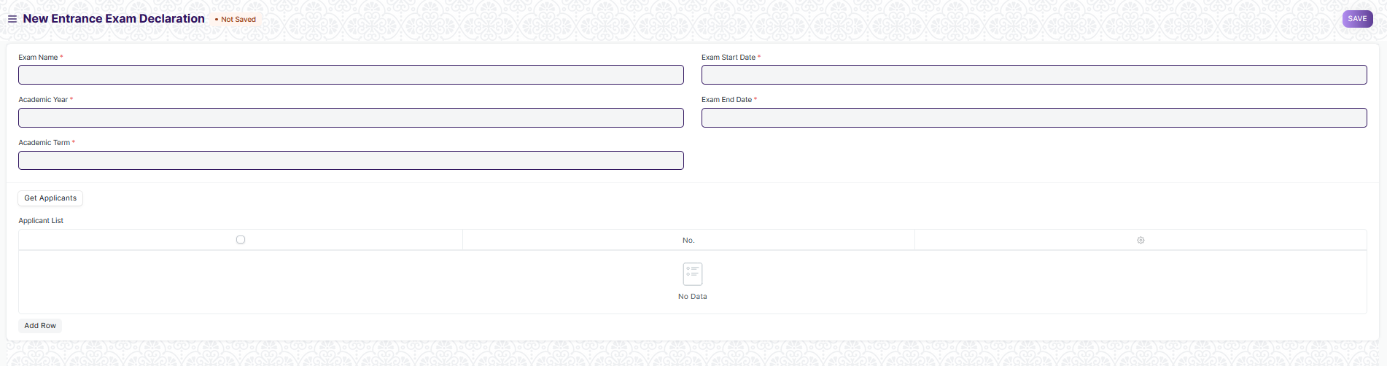

#### **Description of Changes:**

* A new screen where information regarding upcoming exams are stored
* Mandatory Fields include:-
  + Exam Name
  + Academic Year
  + Academic Term
  + Exam Start Date
  + Exam End Date
  + Applicant List

### **Entrance Exam Center Allocation**

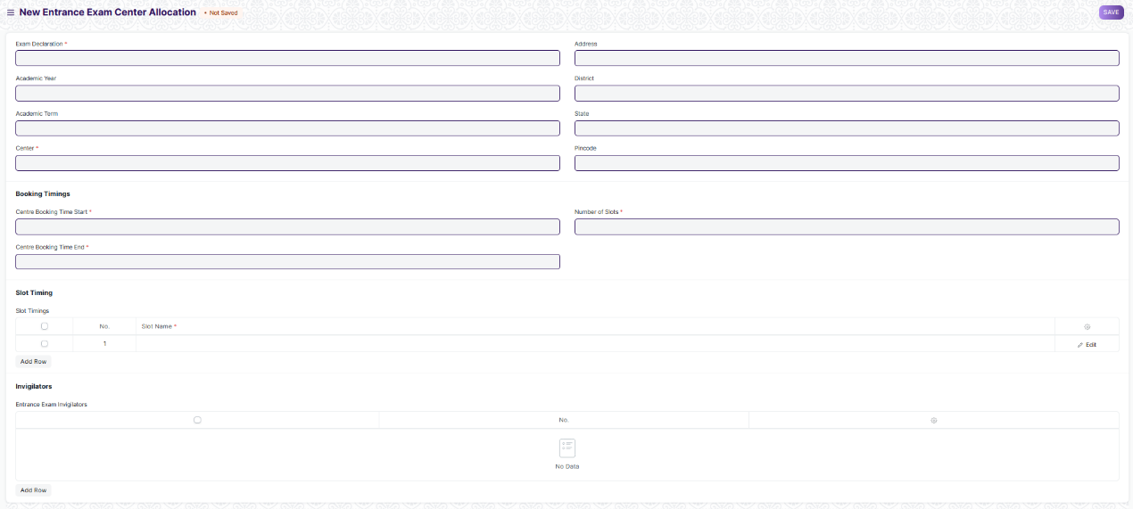

#### **Description of Changes:**

* **A screen where the information regarding exam location and date for the entrance exam is to be allotted and stored.**
* Mandatory Fields include:-
  + Entrance Exam Declaration
  + Exam Date
  + Center Booking Time Start
  + Center Booking Time End
  + Number of Slots
  + Slot Timings
  + Entrance Exam Invigilators

### **Admit Card Generation Tool**

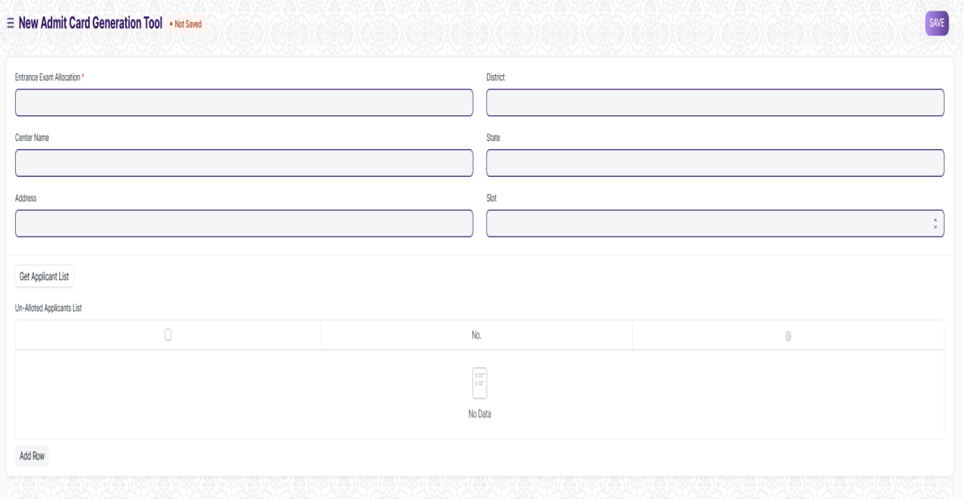

#### **Description of Changes:**

* **A tool to generate multiple admit cards for applicants and also allots them a venue for the exam**
* Mandatory Fields include:-
  + Entrance Exam Allocation
  + Center Name

### **Entrance Exam Admit Card**

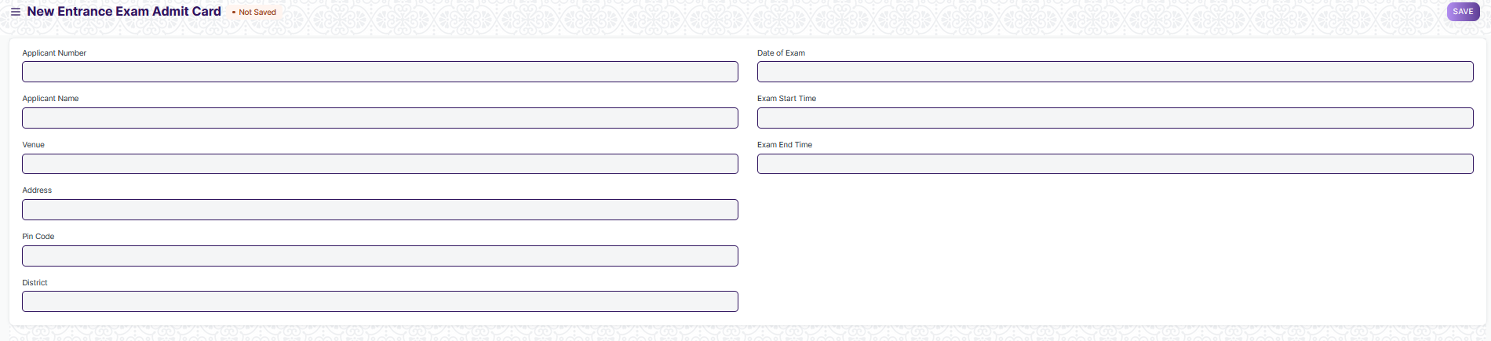

#### **Description of Changes:**

* **A screen which holds information of an individual students admit card**
* **Most of the data in this field will be filled by the Admit Card Generation Tool**

### **Entrance Exam Result Publication**

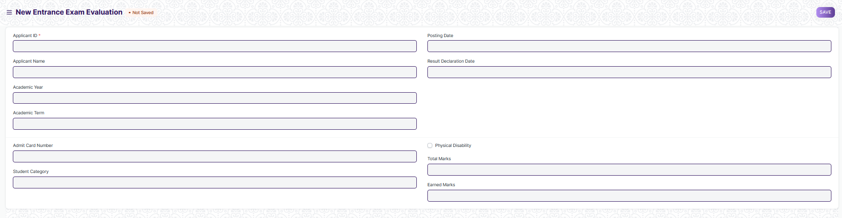

#### **Description of Changes:**

* **A screen which contains the marks of an applicant for the entrance exams and most of the data in this screen will either be manually filled or upload and obtained from an excel sheet**
* Mandatory Fields include:-
  + Applicant ID
  + Posting Date
  + Result Declaration Date
  + Department
  + Student Category
  + Total Marks
  + Earned Marks

### **Rank Card Publication Tool**

### 

#### **Description of Changes:**

* **A screen which used to make large number of rank card**
* Mandatory Fields include:-
  + Entrance Exam Declaration
  + Cutoff Marks
  + Academic Year
  + Posting Date
  + Total Marks

### **Rank Card Masters**

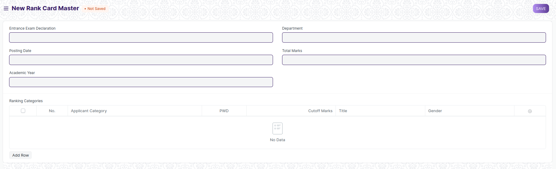

#### **Description of Changes:**

* **A screen which contains the information ranking applicants in the entrance exam .**
* **Data regarding rank cutoff for an applicant based on their category will be stored here**
* Mandatory Fields include:-
  + Entrance Exam Declaration
  + Total Marks
  + Academic Year
  + Depatment

### **Rank Card**

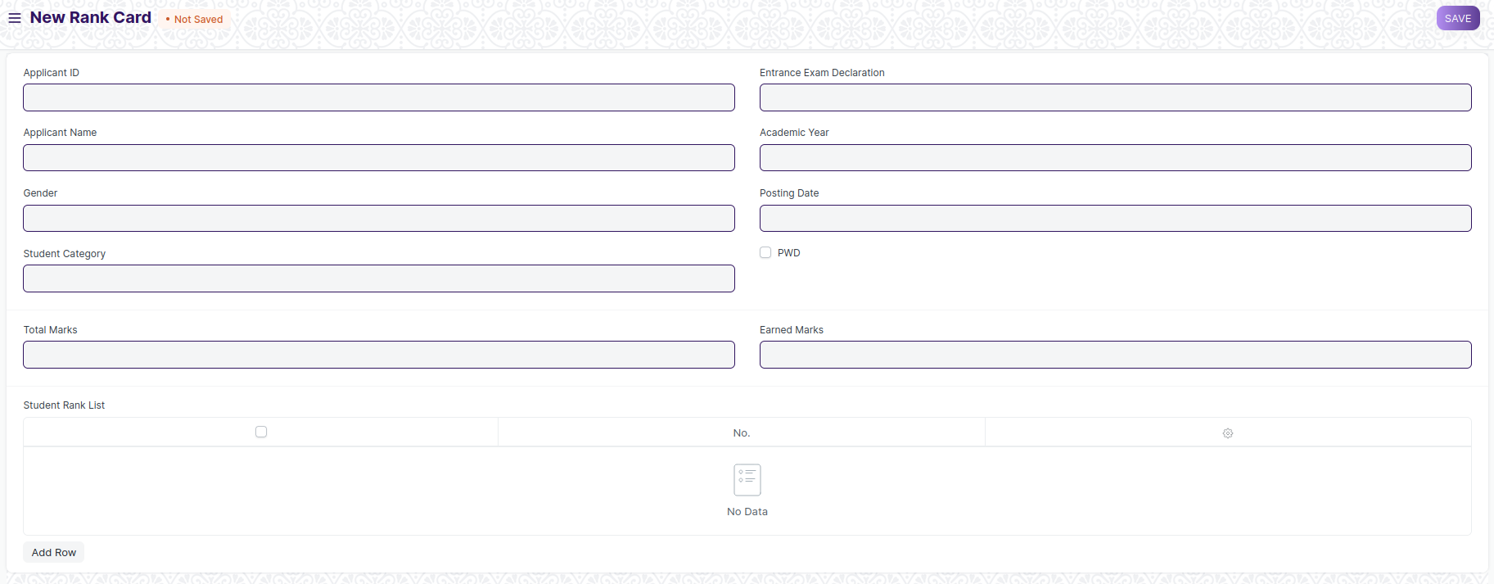

* **A screen which contains the information regarding an applicants rank obtain in the entrance exam.**
* **There is a per-determined cutoff for obtaining a rank. If an applicant didn’t clear the cutoff marks, then he/she won’t be provided with a rank**
* **Data in this screen will be filled as via Rank Publication Tool**

## **Tools**

## **Student Re registration Tool**

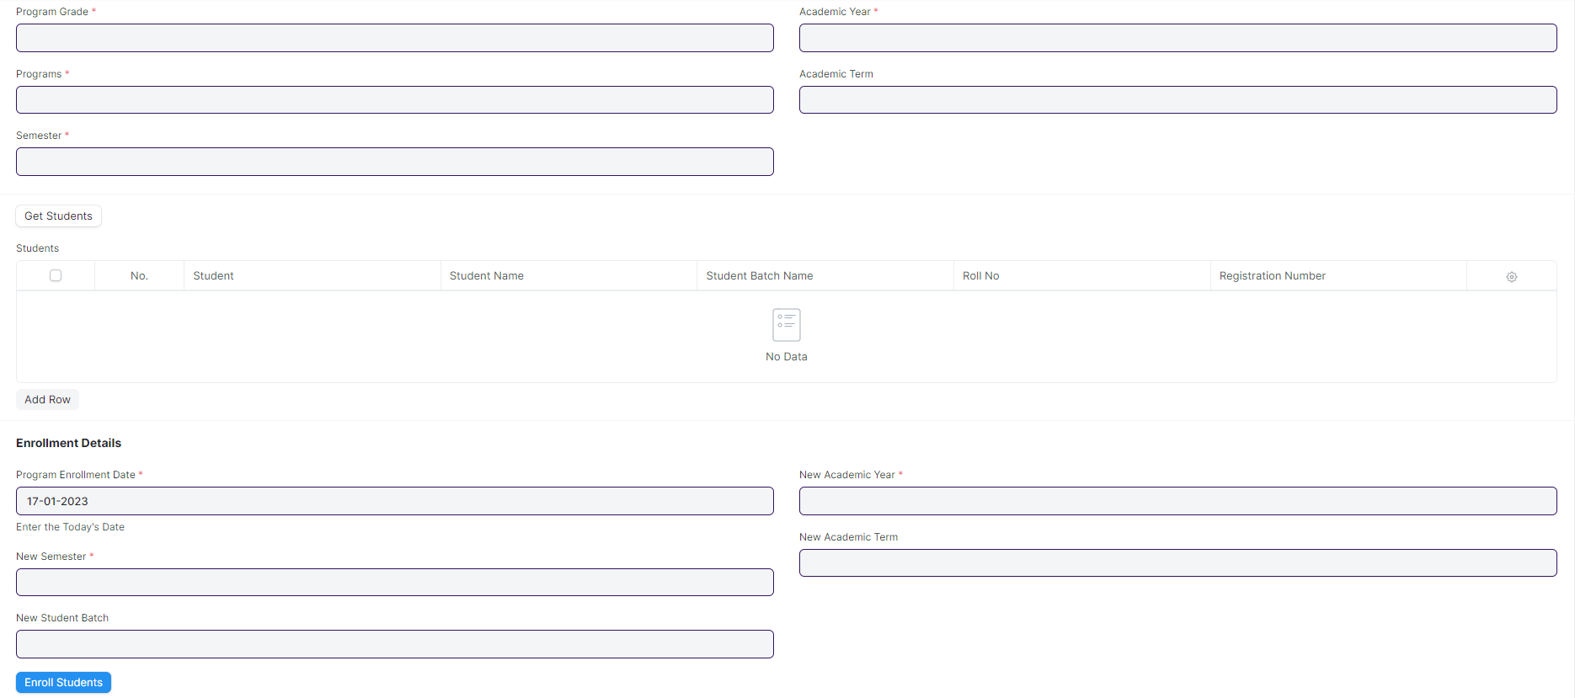

#### **Description of Changes:**

* Program Grade and Programs need to be change to Course Grade and Course.
* And Course Child table need to be change to Module.